1. Compile the SPU_BootLoader project as PS3 platform.
2. Compile the SPU program (like xunittest_test) as PS3_SPU platform.
3. Load the *.self file of SPU_BootLoader by ProDG Debugger.
4. Open Module Properties (File-> Module Properties).
5. Set the file server directory (app_home/) which is the directory of SPU program (*.self) in Module Properties

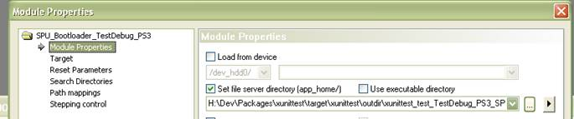

1. Set SPU program’s (*.self) name as Command line parameters in Module Properties

cid:image002.png@01CCE739.10960100.

1. Launch!